Game Design Document

Fill up the following document

1. **Write the title of your project.**

Moon Sheriff.

1. **What is the goal of the game?**

The goal is to navigate your rocket safely to the moon so you can collect coins. Aliens appear and you have to shoot them because they are trying to destroy your rocket.

1. **Write a brief story of your game.**

Humans have decided its time to send another person to the moon. They are sending you up to the moon in an experimental rocket that is controlled by the person on the rocket.

On your way up, you notice many asteroid fields and decide it would be easier to fly through them than to fly around. If you manage to make it through, you land on the moon.

On the moon, you find many collectables and go to collect them, when suddenly aliens start running towards your ship. In fear of your ship being destroyed you pull out your pistol and start shooting the aliens.

After that you head home to share your findings, and you live the rest of your life happily.

- I hope this isn’t too long -

1. **Which are the playing characters of this game?**

* Playing characters are the ones who respond to the user based on the input from the user.
* Cars, monkeys, dinos, wizards, etc., are the playing characters in the game.

|  |  |  |
| --- | --- | --- |
| Number | Character Name | What can this character do? |
| 1 | Fima (f-ih-m-u) | The main character. |
| 2 | Rocket | The rocket the main character flies. |
| 3 |  |  |
| 4 |  |  |
| 5 |  |  |
| 6 |  |  |
| 7 |  |  |
| 8 |  |  |

1. **Which are the Non-Playing Characters of this game?**

* Non-Playing characters are the ones that don't have an action or behavior when the user interacts with the game.
* Hurdles, stones, bananas, coins, etc., are non-playing characters in the game.

|  |  |  |
| --- | --- | --- |
| Number | Character Name | What can this character do? |
| 1 | Coins, moon rocks | Collectables |
| 2 | Asteroids | Obstacles |
| 3 | Aliens | Enemy |
| 4 | Moon, earth | Places |
| 5 |  |  |
| 6 |  |  |
| 7 |  |  |
| 8 |  |  |

Draw your imagination of this game. What does this game look like?

* Draw the game either on your computer or on paper.
* Add images of the game scenes to show each of the playing and non-playing characters at least once.

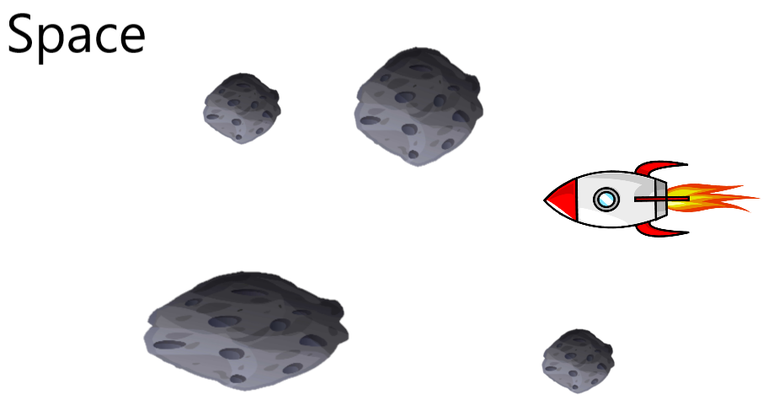

**How do you plan to make your game engaging?**

I’m going to add some interesting cutscenes and some good story.